Dependent Variable: Leaves
R-Square | Coeff Var | Root MSE | Leaves Mean
0.955749 | 7.541966 | 1.572919 | 20.85556

Source | DF | Type III SS | Mean Square | F Value | Pr > F
Trt | 2 | 448.3555556 | 224.1777778 | 148.35 | <.0001
Error-I (Rep(Trt)) | 6 | 9.066667 | 1.511111 | 0.61 | 0.7206
Variety | 9 | 1861.788889 | 206.865432 | 83.61 | <.0001
Variety*Trt | 18 | 566.311111 | 31.461728 | 12.72 | <.0001
Error-II | 54 | 133.600000 | 2.474074
Corrected Total | 89 | 3019.122222

Mean plot
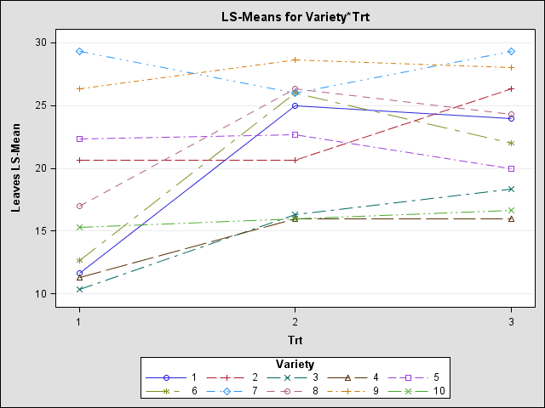

Dependent Variable: Plht
R-Square | Coeff Var | Root MSE | Plht Mean
0.948962 | 7.302463 | 2.499877 | 34.23333

Source | DF | Type III SS | Mean Square | F Value | Pr > F
Trt | 2 | 4814.600000 | 2407.300000 | 197.32 | <.0001
Error-I (Rep(Trt)) | 6 | 73.200000 | 12.200000 | 1.95 | 0.0889
Variety | 9 | 1014.544444 | 112.727160 | 18.04 | <.0001
Variety*Trt | 18 | 372.288889 | 20.682716 | 3.31 | 0.0003
Error-II | 54 | 337.466667 | 6.249383
Corrected Total | 89 | 6612.100000

Mean Plot
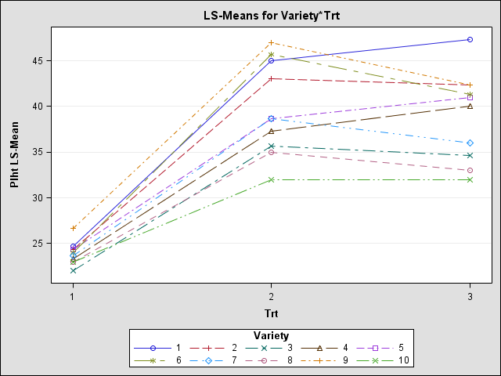

Dependent Variable: LA
R-Square | Coeff Var | Root MSE | LA Mean
0.975780 | 10.25464 | 84.47882 | 823.8111

Source | DF | Type III SS | Mean Square | F Value | Pr > F
Trt | 2 | 5748430.822 | 2874215.411 | 163.63 | <.0001
Error-I (Rep(Trt)) | 6 | 105389.067 | 17564.844 | 2.46 | 0.0355
Variety | 9 | 6068148.456 | 674238.717 | 94.48 | <.0001
Variety*Trt | 18 | 3604335.178 | 200240.843 | 28.06 | <.0001
Error-II | 54 | 385380.27 | 7136.67
Corrected Total | 89 | 15911683.79

Mean Plot
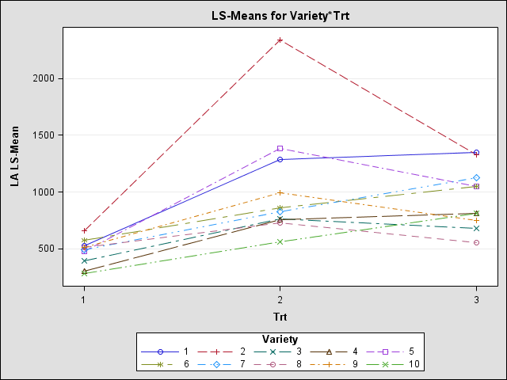

Dependent Variable: SPAD
R-Square | Coeff Var | Root MSE | SPAD Mean
0.934556 | 2.992118 | 1.500093 | 50.13483
3
Source | DF | Type III SS | Mean Square | F Value | Pr > F
Trt | 2 | 63.79470899 | 31.89735450 | 12.56 | 0.0072
Error-I (Rep(Trt)) | 6 | 15.2351852 | 2.5391975 | 1.13 | 0.3588
Variety | 9 | 844.7826279 | 93.8647364 | 41.71 | <.0001
Variety*Trt | 18 | 777.7327160 | 43.2073731 | 19.20 | <.0001
Error-II | 53 | 119.264815 | 2.250280
Corrected Total | 88 | 1822.382022

Mean Plot
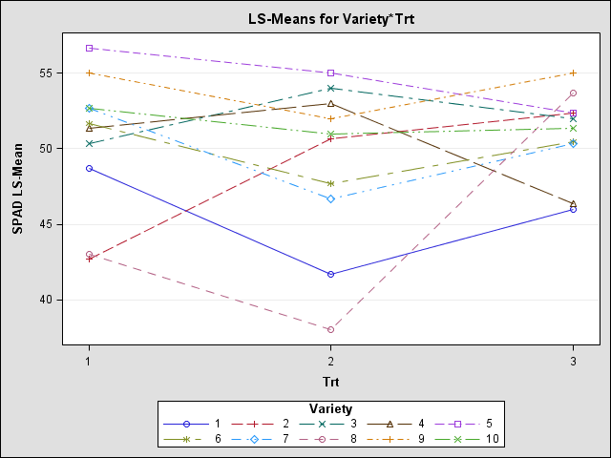

Dependent Variable: TDM
R-Square | Coeff Var | Root MSE | TDM Mean
0.955365 | 11.27097 | 2.394056 | 21.24091

Source | DF | Type III SS | Mean Square | F Value | Pr > F
Trt | 2 | 2601.691247 | 1300.845623 | 38.94 | 0.0004
Error-I (Rep(Trt)) | 6 | 200.435042 | 33.405840 | 5.83 | 0.0001
Variety | 9 | 2101.745819 | 233.527313 | 40.74 | <.0001
Variety*Trt | 18 | 1271.841774 | 70.657876 | 12.33 | <.0001
Error-II | 52 | 298.038292 | 5.731506
Corrected Total | 87 | 6677.292727

Mean Plot
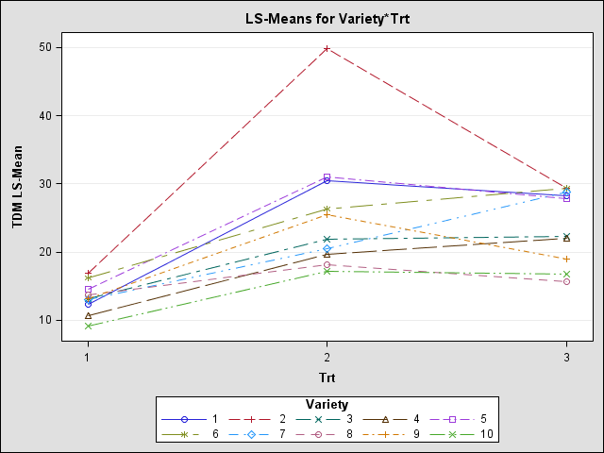

Dependent Variable: PodY
R-Square | Coeff Var | Root MSE | PodY Mean
0.949018 | 12.94684 | 1.429744 | 11.04318

Source | DF | Type III SS | Mean Square | F Value | Pr > F
Trt | 2 | 698.2297949 | 349.1148974 | 34.27 | 0.0005
Error-I (Rep(Trt)) | 6 | 61.1266667 | 10.1877778 | 4.98 | 0.0004
Variety | 9 | 740.8867302 | 82.3207478 | 40.27 | <.0001
Variety*Trt | 18 | 435.1162639 | 24.1731258 | 11.83 | <.0001
Error-II | 52 | 106.296667 | 2.044167
Corrected Total | 87 | 2084.995909

Mean Plot
