3 August 2001
travel
Dr. S. Shanmugasundaram, 2–8 August, on leave; 9–13 August, to Tacoma, USA, to attend and present papers in the Second International Vegetable Soybean Conference; 14–19 August, on leave.
Dr. L.M. Engle, 4–11 August, to participate in Technical Review on Plant Genetic Resources for food and Agriculture Network in Philippines; to discuss preparatory work on entry of AVRDC to SINGER with documentation staff of GRS, IRRI; to discuss evaluation of indigenous vegetable with POP, BPI Economic Garden.
- Source: Yvonne Ting/DAO
An AVRDC Tomato Hybrid Is Being Released in Taiwan
On July 27, 2001, a review panel commissioned by ROC's Council of Agriculture has approved the request submitted by the Taichung District Agricultural Improvement Station for a release of a tomato hybrid developed by the Asian Vegetable Research and Development. A fresh marketing tomato hybrid, FMTT593, is named as "Taichung-AVRDC No. 10." This is the seventh release of AVRDC-developed tomatoes in Taiwan. The hybrid was first synthesized in 1993. However, the development of its female and male parental lines was initiated in 1991 and 1981, respectively. Taichung DAIS took up its regional trials in 1996. Unique traits of this hybrid are dark-green shoulder that Taiwanese consumers crave for, large fruit, firmness, long shelf-life, and resistance to fusarium wilt race 1.
The release of FMTT593 is an outcome of team efforts within and outside AVRDC. In this regard, special credits go to Mr. JT Chen for his passionate striving to move forward this particular hybrid. </blockquote></x-html>
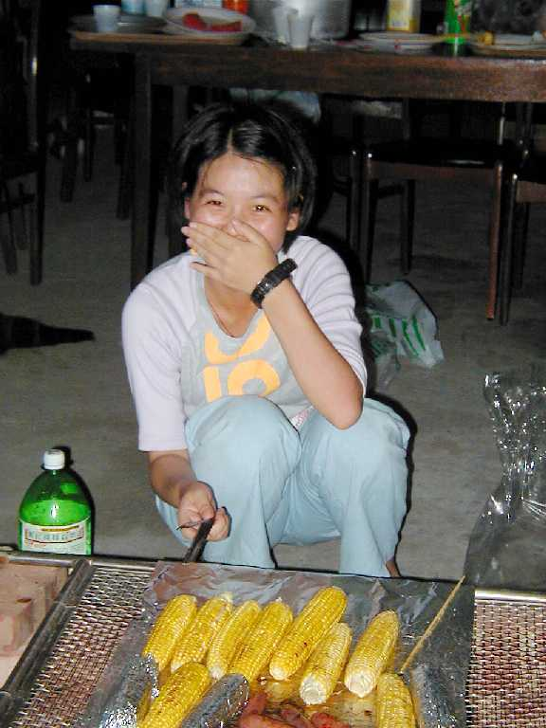
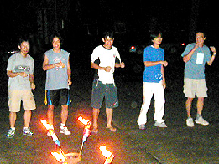亞蔬佳訊快報：第七個亞蔬在台灣命名推廣的番茄品種誕生了！七月二十七日農委會品種命名委員會正式通過亞蔬育成的品種FMTT593，命名為「台中亞蔬十號」。台中亞蔬十號鮮食番茄屬於台灣消費者喜愛的一點紅品種系列，果實大而堅實，圓型，耐貯存，並抗萎凋病。其父母本分別於1981及1991年在亞蔬開始培育。1993年育出雜交一代，1996年起透過台中農業改良場進行區域試驗至今。台中亞蔬十號的育成是亞蔬中心內外相關人員通力合作的成果。其中番茄組陳正次先生鍥而不捨的推動功不可沒。

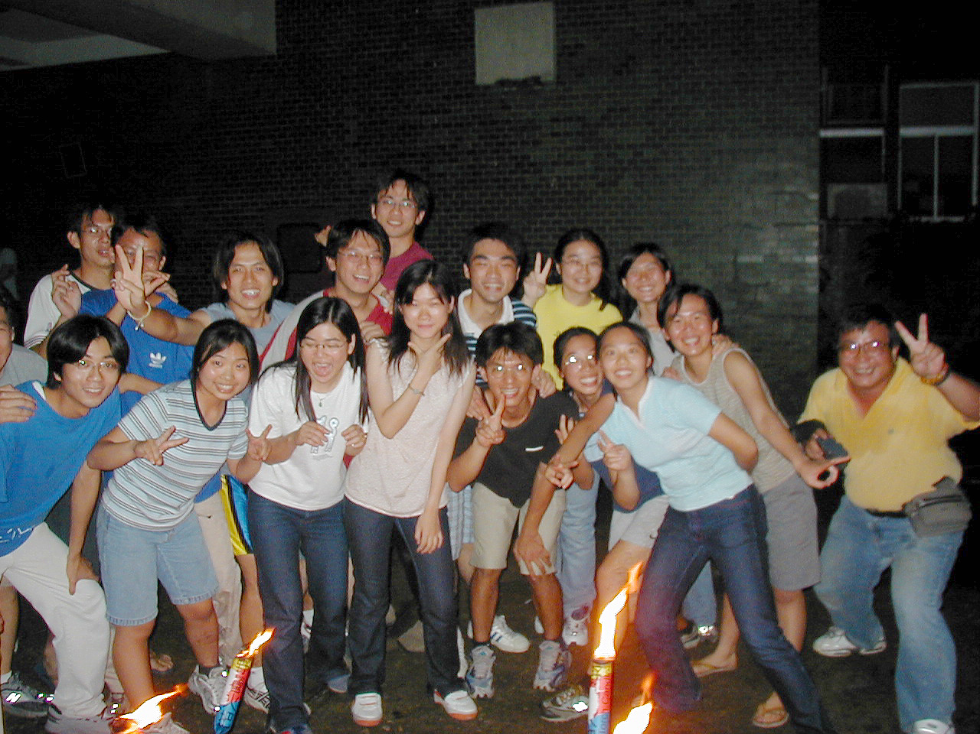ews from the recreation and social committee

- Source: R&S Committee
Humor
What Maturity Has Taught Me
- I’ve learned that you cannot make someone love you. All you can do is stalk them and hope they panic and give in.
- I’ve learned that you shouldn’t compare yourself to others – they are more screwed up than you think.
- I’ve learned that regardless of how hot and steamy a relationship is at first, the passion fades, and there had better be a lot of money to take its place.
- I’ve learned that 99% of the time when something isn’t working in your house, one of your kids did it.
- I’ve learned that the people you care most about in life are taken from you too soon and all the less important ones just never go away.
- Source: OPC

this week’s movies in tainan and matou
Theater/Location | Film
Nan-Du 南都  (138, Yu-Ai St.)  Tel: 222-2383 | The Mummy Returns 神鬼傳奇2  Pearl Harbor 珍珠港  Jurasic Park III 侏羅紀公園3  決戰星球  The Lost Empire 失落的帝國 | Lara Croft: Tomb Raider  蘿拉卡芙特古墓奇兵  龍吻  Shrek 史瑞克
Nan-Tai 南台  (317, Yu-Ai St.)  Tel: 223-2426 | The Mummy Returns 神鬼傳奇2  Pearl Harbor 珍珠港  Jurasic Park III 侏羅紀公園3  龍吻 | 決戰星球  Lara Croft: Tomb Raider  蘿拉卡芙特古墓奇兵
Kuo-Hwa 國花  (118, Min-Chuan Rd. Sec. 2)  Tel: 226-1213 | Spy Kids 小鬼大間諜  Dr. Doolittle 2 怪醫杜立德  Moulin Rouge 紅磨坊  Pearl Harbor 珍珠港  Cats & Dogs 貓狗大戰 | 龍吻  驚聲尖笑2  A.I. 人工智慧  生死極速
Ma-Tou 麻豆  (106-7, Hsing-chung Rd.,  Ma-Tou) Tel: 572-2159 | Pearl Harbor 珍珠港  老夫子 | Spy Kids 小鬼大間諜  Dr. Doolittle 2 怪醫杜立德2
- Source: OPC

 | Weather Summary (26–31 July 2001)
 | Temperature (°C) | Max |  | Min. |  | Monthly precipitation record (mm)
 | Absolute | 33.5 |  | 23.6 |  | Accumulation to date | 221.8
 | Weekly mean | 32.1 |  | 25.2 |  | Normal (July) | 402.8
 | Normal (July) | 32.5 |  | 24.7
 |  |  |  |  |  | Yearly precipitation record (mm)
 | Relative humidity (%) | 95.0 |  | 61.2 |  | Accumulation to date | 1493.8
 | Evaporation (mm) |  | 49 |  |  | Normal (January to July) | 1118.4

