2 March 2001
travel
Mr. David Abbass, 11–13 March, to Bangkok, Thailand, to give lecture to trainees of ARC’s 19th Regional Training Program.
- Source: ASU/DAO
Seminar Announcement
Speaker : Mr. Chen Ming-che (陳明哲)
Topic : How to use PowerPoint for presentations
（如何應用PowerPoint輔助演講）
Time : 1500–1600 hours, 7 March 2001 (Wednesday)
Venue : Conference Room I, 2nd floor, Chandler Hall
Language : Chinese
All are welcome!
- Source: Nationally Recruited Research Staff Committee
news from the avrdc goodwill club
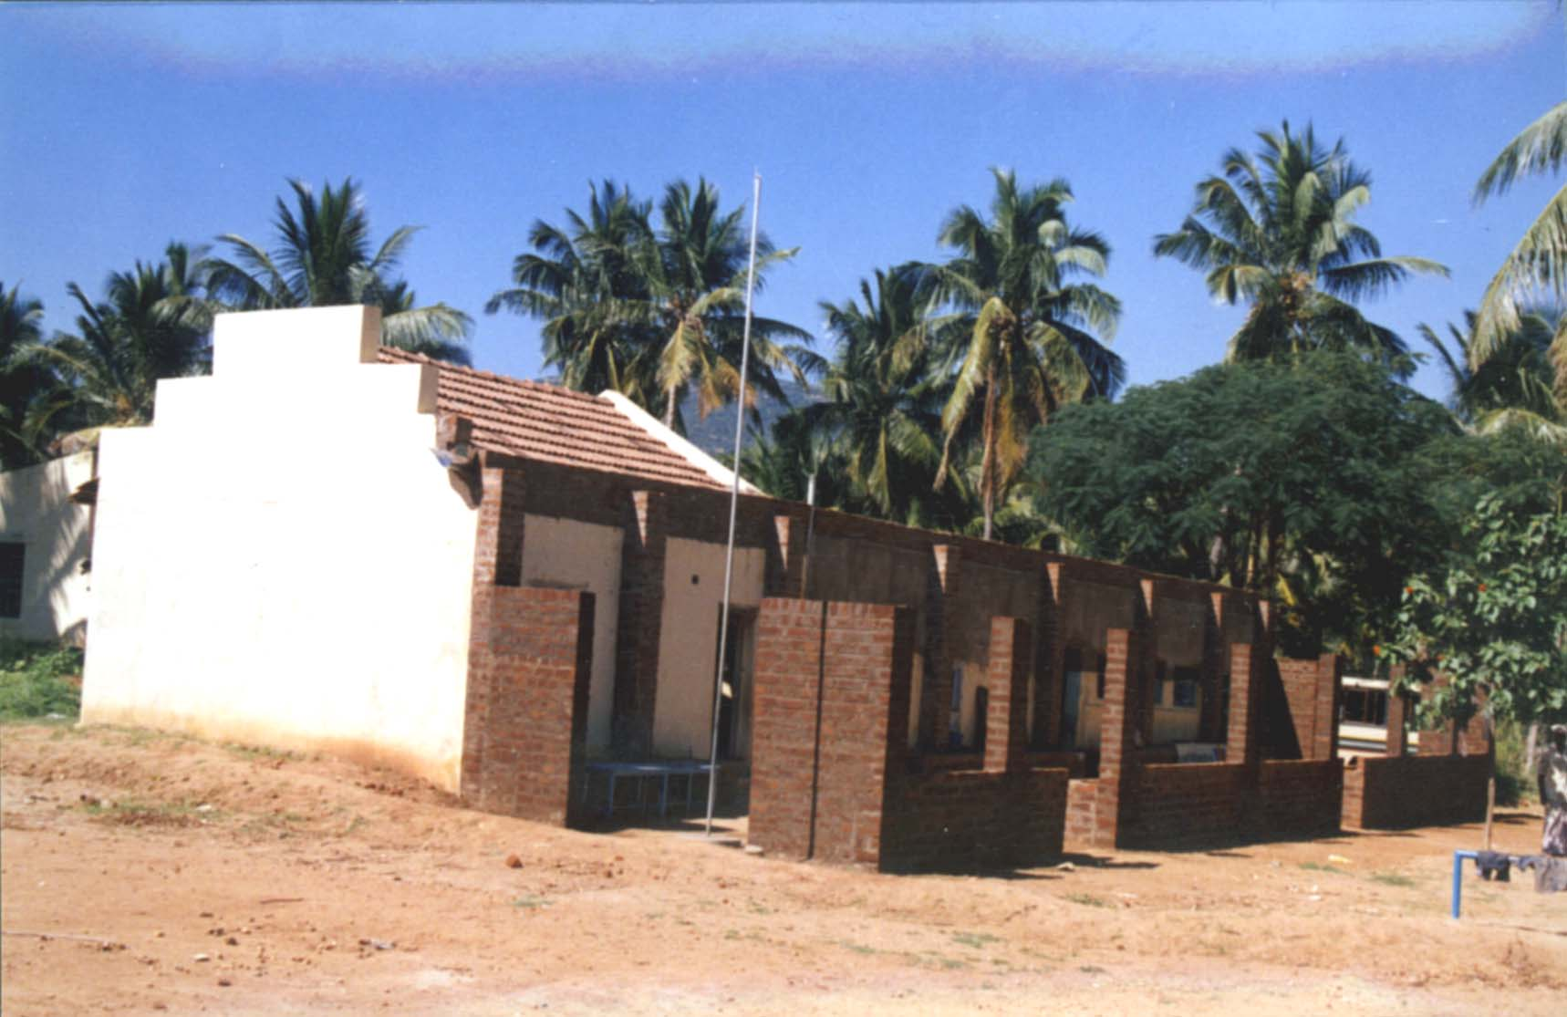
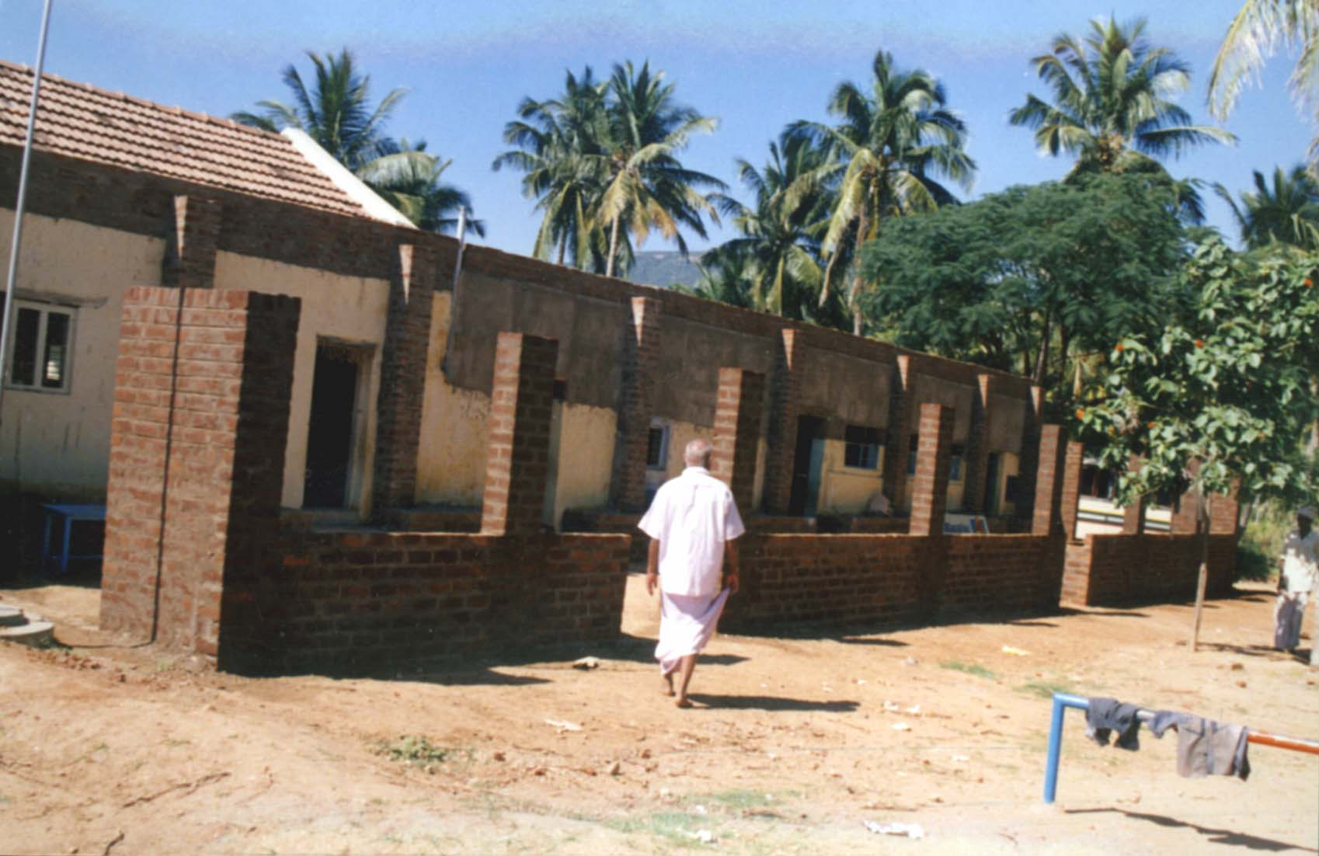
This is follow-up news from the AVRDC Goodwill Club’s activity reported in Newsletter dated 8 September 2000. Mrs. Irene Tsou, Chairperson, on behalf of AVRDC Goodwill Club, donated US$1,000 to Swami Vivekananda Vidyalaya School in India—a charity school that provides free education to tribal children—for the construction of a classroom. Recently we received a letter from Dr. Manickam providing pictures of the above-mentioned classroom. We are glad that the AVRDC Goodwill Club has been able to help the school. Education is always an important and first priority job for all children around the world. We appreciate all donations either from our members or others. Cheer up and join us—AVRDC Goodwill Club! For donations please contact: Dr. Peter Hanson (ext. 370), Mrs. Mitzi Abbass (ext. 805), Mr. Jim Fu (ext. 210), Ms. Ray-yui Yang (ext. 432), Ms. Huei-mei Chen (ext.362), Ms. Lydia Wu (ext. 240), and Ms. Letty Lin (ext. 504).
亞蔬愛心社追蹤報導：去年九月八日亞蔬新聞週刊刊載，愛心社長鄒太太代表愛心社捐贈壹仟元美金，給印度南部山地村一所小型慈善學校（Swami Vivekananda Vidyalaya School），讓他們興建教室解決教室不足的困境。最近很高興接到Dr. Manickam的來信，提供了即將完工的教室照片，我們欣慰愛心社能對學校有些微助益，我們也相信教育對全世界的兒童而言，永遠是重要和優先的神聖工作。感激愛心社社員及社友持續性不計較的付出，當然，金錢上的幫助是最直接的，請大家多多以行動支持鼓勵愛心社吧！捐款請聯絡以下人員：Dr. Peter Hanson（分機370）、Mrs. Mitzi Abbass（分機805）、傅懋森先生（分機210）、楊瑞玉小姐（分機432）、陳惠美小姐（分機362）、吳穗芳小姐（分機240）、林麗雪小姐（分機504）。
- Source: Lydia Wu/AVRDC Goodwill Club（吳穗芳/亞蔬愛心社）
humor
On counterfeiting: A convenience store clerk in Abilene, Texas, was passed a counterfeit $100 bill – and accepted it without question . . . even though it was a foot long and five inches wide.
- Source: OPC
news from the recreation and social committee
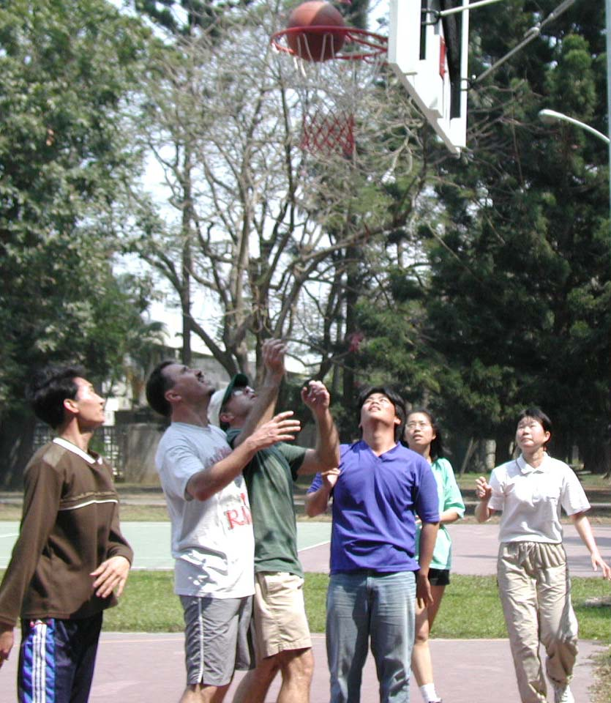
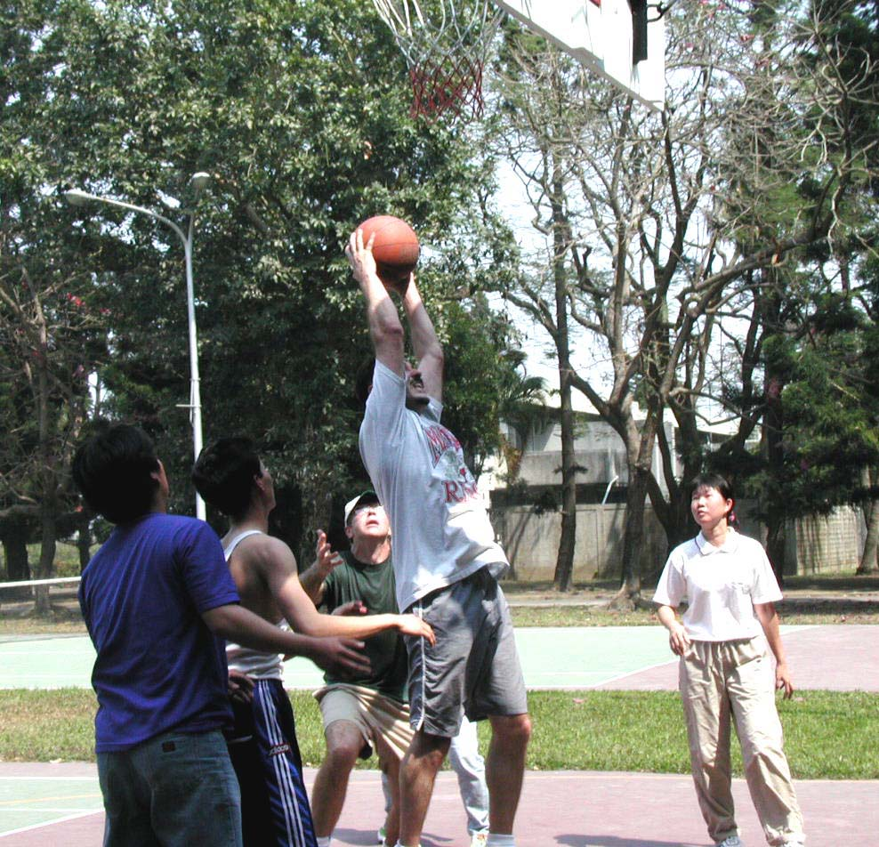
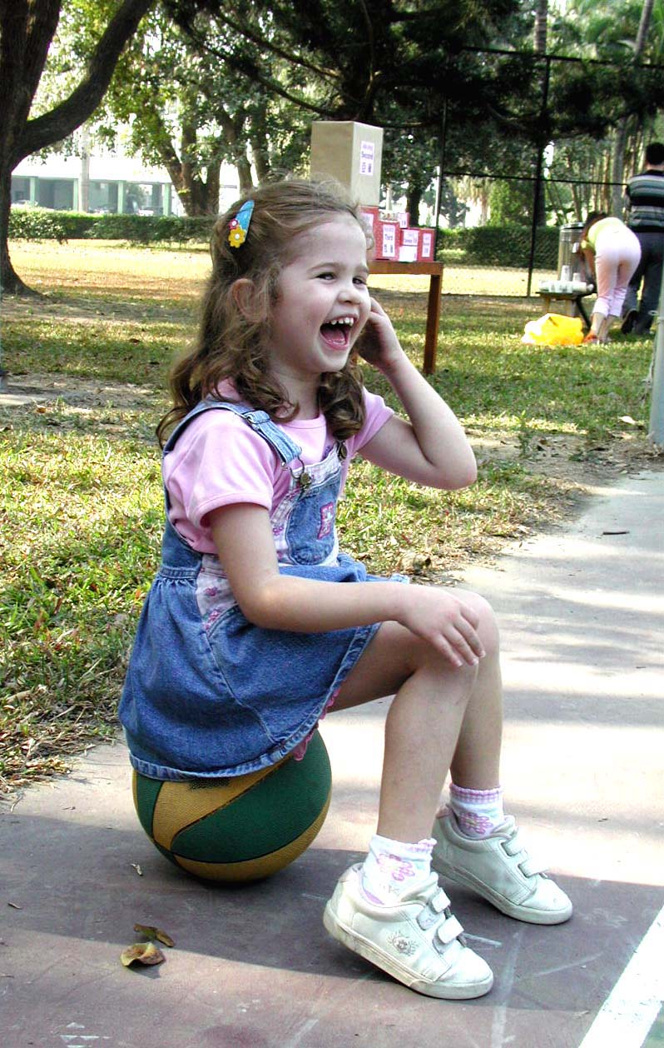
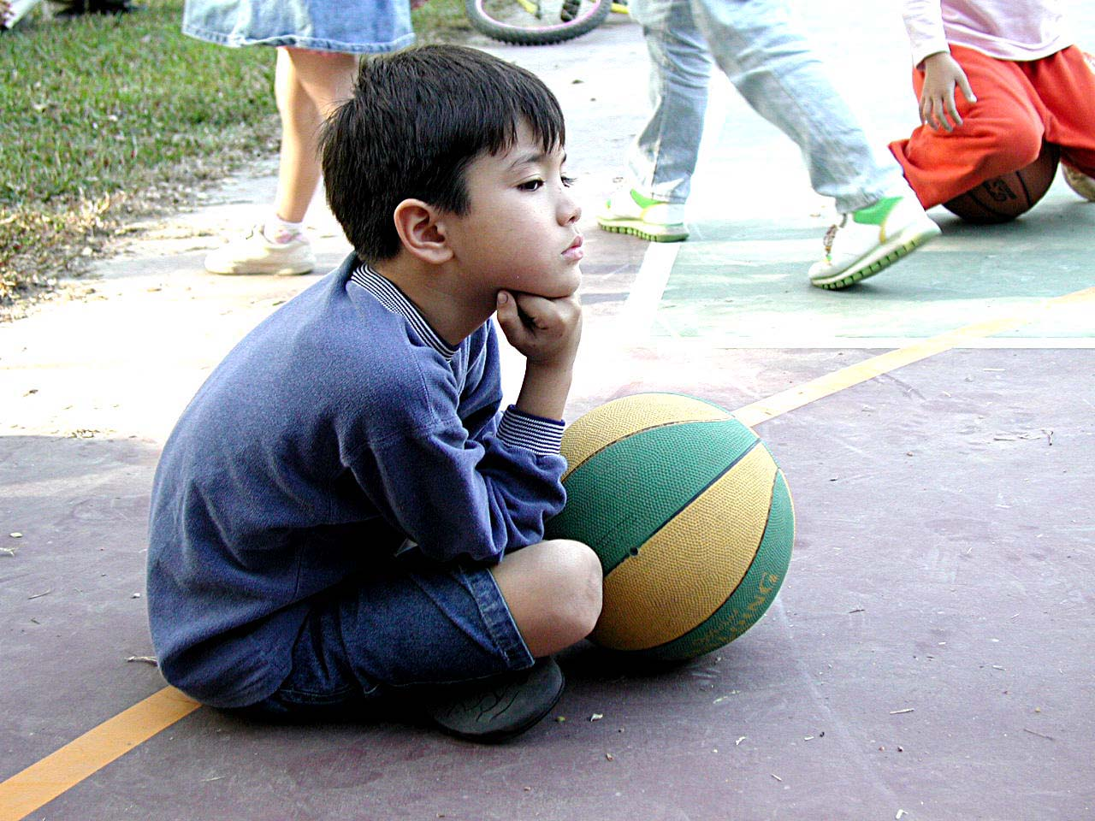
Lots of Fun at AVRDC Basketball Tournament!
(Counterclockwise: Elizabeth Hanson, Nicholas Abbass, Team B v.s. Team D)
Thanks to everyone for participating in this year’s basketball tournament. It was lots of fun! In the 3-on-3 team contest, congratulations go to powerful Team B: Rachel Ko, Makoto Kamijo, Ku Ja-hwan, Zong-hsiang Wang, and Peter Hanson. Runner-up was Team D: Jessica Chang, Vu Thanh Hai, David Abbass, Markus Kaiser, and Tom Kalb. The top shooter in the Hot Shot Contest was Lee-hua Yang. Other semi-finalists were Mau-long Ma, Rachel Ko, and L.L. Black. Special thanks to Rachel Ko and the rest of the Recreation Committee for organizing the best basketball tournament ever at AVRDC! Next month’s activity is badminton. Please contact Wen-min Chiang (ext. 225) or Vanna Yung-chi Liou (ext. 555) if you would like to play!
籃球賽大成功！大夥兒都玩得頗為盡興！鬥牛賽冠軍是:辜瑞雪、Makoto Kamijo,、Ku Ja-hwan、王宗詳、Peter Hanson。亞軍是：張淨環、Vu Thanh Hai、David Abbass、Markus Kaiser、Tom Kalb。投籃大賽冠軍是楊麗樺，其他優勝者依序為：馬茂隆、辜瑞雪、L.L. Black。特別感謝籃球賽負責人辜瑞雪以及大力幫忙的康委員會委員們！三月份的運動比賽項目是羽球，請向江文明（分機225）或劉永琪（分機555）報名。
- Source: Recreational and Social Committee
this week’s movies in tainan and matou
Theater/Location | Film
Nan-Du 南都  (138, Yu-Ai St.)  Tel: 222-2383 | Vertical Limit 巔峰極限  Meet the Parents 門當父不對  Thirteen Days 驚爆13天 | Cast Away 浩劫重生  Forgotten or Forgiven 衝鋒陷陣  What Women Want 男人百分百
Nan-Tai 南台  (317, Yu-Ai St.)  Tel: 223-2426 | The Legend of Bagger Vance 重返榮耀  Snatch 偷拐搶騙  Thirteen Days 驚爆13天 | Forgotten or Forgiven 衝鋒陷陣  Meet the Parents 門當父不對  Cast Away 浩劫重生
Kuo-Hwa 國花  (118, Min-Chuan Rd. Sec. 2)  Tel: 226-1213 | Proof of Love 千驚萬險  A Fighter’s Blue 阿虎  Thirteen Days 驚爆13天  Chocolat 濃情巧克力 | Bounce 當真愛來敲門  Nurse Betty 當真愛來找碴  Pay It Forward 讓愛傳出去
Ma-Tou 麻豆  (106-7, Hsing-chung Rd.,  Ma-Tou) Tel: 572-2159 | Vertical Limit 巔峰極限  A Fighter’s Blue 阿虎 | Bless the Child 靈異總動員  2001: A Space Travesty 脫線帝國
- Source: OPC

 | Weather Summary (22–28 February 2001)
 | Temperature (°C) | Max |  | Min. |  | Monthly precipitation record (mm)
 | Absolute | 31.4 |  | 14.4 |  | Accumulation to date | 0
 | Weekly mean | 27.5 |  | 17.1 |  | Normal (February) | 30.9
 | Normal (February) | 24.1 |  | 12.9
 |  |  |  |  |  | Yearly precipitation record (mm)
 | Relative humidity (%) | 97.481.6 |  | 58.3 |  | Accumulation to date | 42.0
 | Evaporation (mm) |  | 29.4 |  |  | Normal (January to February) | 48.2

