23 February 2001
travel
Dr. Jürgen Friedrichsen, 24 February–3 March, on leave.
- Source: ASU/DAO
new irri address
The International Rice Research Institute Library in the Philippines has a new mailing address as follows: Library and Documentation Service, International Rice Research Institute, DAPO Box 7777, Metro Manila, Philippines; courier address: 6776 Ayala Ave., Suite 1009, Condominium Center, Makati City, Philippines; tel.: (63-2) 891-1236, 891-1258; fax: (63-2) 891-1174; Los Baños Research Center tel.: (63-2) 845-0563, 844-3351; fax: (63-2) 891-1291; email: <postmaster-irri@cgiar.org>.
- Source: OPC
telephone Suspension
There will be a two-hour telephone cut from 1200 to 1400 hours, Thursday, 1 March, while Chunghwa Telecom Co. splices the newly laid cable per the Center’s request.
停話通知—3月1日（星期四）中午12點至下午2點，因中華電信換裝電纜，本中心電話將斷訊兩小時。
- Source: J.H. Chen/Buildings and Maintenance
power cut
The power will be cut from 0800 to 1200 hours next Saturday, 3 March, throughout the Center while work is done on underground cable.
停電通知—3月3日（星期六）上午8點至中午12點，因更換新市線的地下電纜線，中心將暫停供電。
- Source: J.H. Chen/Buildings and Maintenance
Friendly Reminder for Flower Lovers
Some flowers have been mysteriously picked from campus residents’ gardens. While we all know that flowers planted here in the campus are pretty to look at, please be reminded not to pick them without asking permission first from the resident owners.
住宅區庭院裏綻放的花朵，近來常神秘失蹤，雖然花開堪折直須折，但是漂亮的花大家一起欣賞，不是更好！愛花人士如果真的很想擁有它，請向主人打聲招呼吧！
- Source: OPC
news from the recreation and social committee
AVRDC Basketball Tournaments
Join us for lots of fun at the basketball court this Wednesday, 28 February! During recreation time (1500–1645 hours), we will hold the 2nd Annual AVRDC Hot Shot Basketball Contest. Everyone is welcome to play! The rules are described below. There will be lots of prizes and fun! The 3-on-3 Tournament is already underway, with four teams playing for the championship. The championship game is scheduled for 1200 hours, also on Wednesday, 28 February. After eating a quick lunch, please cheer for our teams. After the championship game, you can practice for the afternoon’s Hot Shot contest! If work on Wednesday is cancelled, the basketball championships will be postponed until the following week. Stay tuned for future announcements.
2月28日（星期三）下午的全員運動時間（3點到4點45分），是亞蔬第二屆投籃比賽的日子，每個人都可以參加比賽，不想參賽的人也別忘了到籃球場來助陣！精彩好玩又有很多獎品可得喔！3對3的鬥牛賽已開打，共有四隊角逐冠軍寶座，冠軍爭奪賽已訂在2月28日（星期三）中午12點開始，精彩可期千萬別錯過了！吃過午飯之後就請大家移駕到籃球場去加油，賽後還可為下午的投籃賽暖身，何樂而不為呢！如果下週三放假，籃賽則延後一週舉行，請敬候通知！
- Source: Recreational and Social Committee
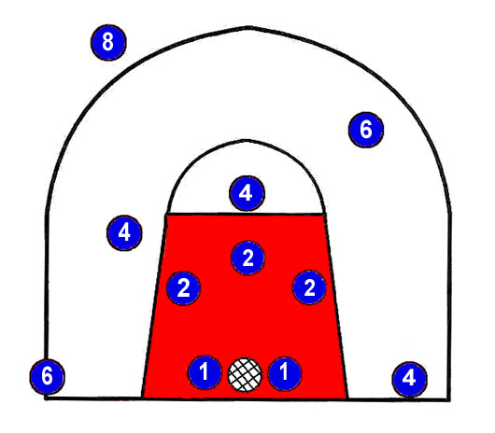AVRDC Hot Shot Basketball Rules
1. Points will be given for each shot as shown in the left diagram.（進球得分數—如圖所示之投籃位置）
2. The player begins at the free-throw line with the ball.
（參賽者由罰球線開始投籃）
3. Each player can score only two lay-ups.
（籃下投籃得分，只可投兩次）
4. When shooting a basket, the player must have his/her feet in the shooting spot.
（投籃時一隻腳必須踩在所畫的圈圈裏）
5. Each player will shoot for 60 seconds. The last shot must leave the player's hand before the final whistle sounds.（計分時間為60秒，哨音響起之前球離手，進球才算得分）
6. The eight players with the highest scores will advance to the semifinals. The top four players in the semifinals will shoot for the championship.（前八強可進級半準決賽，進入半準決賽的前四強可爭奪冠軍）
- Source: Recreational and Social Committee
（亞蔬年度投籃賽規則）

Thanks from mr. Wu jen-hui
Mr. Wu Jen-hui, Chief, AVRDC Post Office, will be transferred to Da-nai Post Office effective 27 February. He would like to take this opportunity to thank AVRDC’s staff for their support, cooperation, and friendship during the past more than eleven years.
亞蔬郵局局長—吳振輝先生將於2月27日調至大內郵局服務，吳局長感謝大家這11年多以來對亞蔬郵局的照顧、指導與合作！
- Source: OPC
this week’s movies in tainan and matou
Theater/Location | Film
Nan-Du 南都  (138, Yu-Ai St.)  Tel: 222-2383 | Vertical Limit 巔峰極限  Meet the Parents 門當父不對  Snatch 偷拐搶騙  Remember the Titans 天公金 | Cast Away 浩劫重生  Forgotten or Forgiven 衝鋒陷陣  Cherry Falls 都是處女惹的禍
Nan-Tai 南台  (317, Yu-Ai St.)  Tel: 223-2426 | The Legend of Bagger Vance 重返榮耀  Snatch 偷拐搶騙  What Women Want 男人百分百  Vertical Limit 巔峰極限 | Forgotten or Forgiven 衝鋒陷陣  Meet the Parents 門當父不對  Cast Away 浩劫重生
Kuo-Hwa 國花  (118, Min-Chuan Rd. Sec. 2)  Tel: 226-1213 | The Accidental Spy 特務迷城  Proof of Love 千驚萬險  A Fighter’s Blue 阿虎 | Bounce 當真愛來敲門  Nurse Betty 當真愛來找碴  Highlander Endgame 超時空聖戰
Ma-Tou 麻豆  (106-7, Hsing-chung Rd.,  Ma-Tou) Tel: 572-2159 | Vertical Limit 巔峰極限  A Fighter’s Blue 阿虎 | 102 Dalmatians 102真狗  Boys and Girls 擋不住的愛妹
- Source: OPC

 | Weather Summary (15–21 February 2001)
 | Temperature (°C) | Max |  | Min. |  | Monthly precipitation record (mm)
 | Absolute | 27.4 |  | 12.0 |  | Accumulation to date | 0
 | Weekly mean | 25.4 |  | 15.5 |  | Normal (February) | 30.9
 | Normal (February) | 24.1 |  | 12.9
 |  |  |  |  |  | Yearly precipitation record (mm)
 | Relative humidity (%) | 97.781.6 |  | 53.1 |  | Accumulation to date | 42.0
 | Evaporation (mm) |  | 19.9 |  |  | Normal (January to February) | 48.2

