29 March 2002
travel
Dr. Mubarik Ali, 29 March, to Thailand, to discuss with Dr. Koizumi about the publication of CLV report; 30 March–7 April, on leave; 8–15 April, to Hanoi, Vietnam, to initiate the peri-urban Hanoi impact study.
Dr. Samson C.S. Tsou, 2–7 April, to USA, to attend the USAID-Integrated Pest Management Collaborative Research Support Program (IPM-CRSP) Board Meeting of 2002, at the Virginia Tech University campus in Blacksburg, Virginia.
- Source: Yvonne Ting/DAO
WELCOME
Ms. Rozina Afroz Chhanda, Research Intern from Bangladesh Agricultural Research Institute (BARI), arrived at AVRDC on 27 March 2002 for 5 months of training under Dr. Engle’s guidance. Ms. Chhanda is a Scientific Officer at BARI. During this period, she will work on characterizing indigenous vegetables based on standard descriptors; developing a database on GRSU germplasm accessions originating from Bangladesh; and observing regeneration, preservation and documentation procedures practiced at GRSU. She can be contacted at ext. 533 (office) and ext. 875 (dormitory), <rafrozbd@netra.avrdc.org.tw>.
- Source: Rose Chan/Program III
SEMINAR ANNOUNCEMENT
Speaker : Dr. Paul A. Gniffke
Title : Paprika Pepper Development for California
Time : 1330–1500 hours, Monday, 1 April (coffee will be served afterwards)
Venue : Conference Room I, 2nd floor, Chandler Hall
All are welcome!
- Source: Teresa Liang/Program I
news from the open house committee
Open House Change of Date: Wednesday, 1 May
The AVRDC Open House date has been changed from Friday, 26 April to Wednesday, 1 May. This change was the result of the AVRDC’s decision to have the ROC COA co-host the event. This change in date may have an effect on some of the field demonstrations and therefore scientists are kindly asked to make a note of the later date and prepare their demonstrations accordingly. The Open House Committee kindly thanks all at the AVRDC for their attention to this matter.
What’s in a Name?
The Open House Committee would like to announce that as of today, no winner has been chosen in the contest for naming the Open House in Chinese. The winner will receive NT$1000. All entries must be forwarded to Kathy <kathy@netra.avrdc.org.tw> at ext. 502.
「Open House」中文名稱仍在徵求中，投稿請送交陳德瑛（分機502, <kathy@netra.avrdc.org.tw>），命名被採用者可獲頒獎金新台幣壹仟元。
- Source: Open House Committee
AVRDC TO APPEAR ON SAN LIH TELEVISION TONIGHT AT 10:00 PM
AVRDC will be featured on national television this evening (Friday, 29 March) on San Lih Television at 10:00 pm. The show is entitled “A Look at Taiwan” and this week will introduce the town of Shanhua and the AVRDC. While cable channels may vary by company, San Lih TV should be Channel 29 in both Shanhua and Tainan. Certainly programming worth watching.
今晚10點29頻道的三立電視台所製作的「用心看台灣」節目會介紹善化及亞蔬中心，屆時希望大家能準時觀賞！
- Source: CTO
Filipino Summer Student Donation Fund
The good news is that we have 15 Filipino summer students coming. Some of them will arrive next week! The bad news is that we have stipends for only 8 of them. The students have agreed to share the stipends. Their professors at UPLB, however, have asked AVRDC if there is any possible way to give a few more funds to these students (who are among the finest in their class). A couple students, in particular, are from very poor families. If anyone would like to donate a few dollars to share with these students, please give it to the Training Office. Once all funds are collected, we will ask the professors for their advice on distributing the money. Thanks!
有個好消息是—將有15位菲律賓的暑假生要來中心，有幾位下星期就會抵達，但壞消息是—只有8位有獎學金補助，而學生們同意分攤僅有的獎學金，菲律賓大學學生們的指導教授，希望亞蔬的朋友能贊助他們一些，這些學生都是班級裏的佼佼者，但都大部分是來自於貧窮的家庭。請將捐獻款項繳交訓練組，請他們的指導教授統一分配給學生們。謝謝！
- Source: Dr. Tom Kalb/CTO
new email address
Ms. Su Min-mei, Kasumi (蘇旻鎂), Research Assistnat (ADB Project), GRSU, Program III, <kasumi@netra.avrdc.org.tw>.
- Source: Shirley Chen/Computer Services Unit
Charity Sale to benefit Goodwill Club
Mr. J.H. Chen, Superintendent of the TSO, has kindly offered his bicycle, won in the raffle during last year’s AVRDC festival (valued at NT$1,500), for sale. The bicycle is currently in the FDS manager’s office. Proceeds from the sale of the bicycle will be donated to the AVRDC’s Goodwill Club. Anyone interested in bidding on the bicycle is requested to contact Ms. Lydia Wu (ext. 240) before 3:00 pm next Wednesday, 3 April.
承蒙技術服務科科長陳振華先生熱心贊助捐獻出去年年底中心歲末聯歡會摸彩獎品—價值1500之全新腳踏車供同仁認購，得款將悉數捐給亞蔬中心愛心社，做為慈善基金。有興趣的同仁請於下週三（4月3日）下午三點前向吳穗芳（分機240）出價競標！
- Source: AVRDC Goodwill Club
this week in technology history
1946–The US Census Bureau and NBS discuss UNIVAC purchase: The Census Bureau and the National Bureau of Standards met on this day in 1946 (March 28th) to discuss the purchase of a computer. The agencies agreed to buy UNIVAC, the world’s first general all-purpose business computer, from Presper Eckert and John Mauchly for a mere $225,000; unfortunately, UNIVAC cost far more than that to develop. Eckert and Mauchly’s venture foundered as the company continued to build and program UNIVACs for far less than the development cost. Eventually, the company was purchased by Remington Rand.
And on a less brighter technology historical note...
1979–Nuclear accident at Three Mile Island, USA: At 4:00 am on March 28, 1979, the worst accident in the history of the U.S. nuclear power industry begins when a pressure valve in the Unit-2 reactor at Three Mile Island fails to close. The Three Mile Island nuclear power plant was built in 1974 on a sandbar on Pennsylvania’s Susquehanna River, just 10 miles downstream from the state capitol in Harrisburg. The unharmed Unit-1 reactor at Three Mile Island, which was shut down during the crisis, did not resume operation until 1985. Cleanup continued on Unit-2 until 1990, but it was too damaged to be rendered usable again. In the more than two decades since the accident at Three Mile Island, not a single new nuclear power plant has been ordered in the United States.
- Source: CTO
AVRDC Basketball Tournament Does It
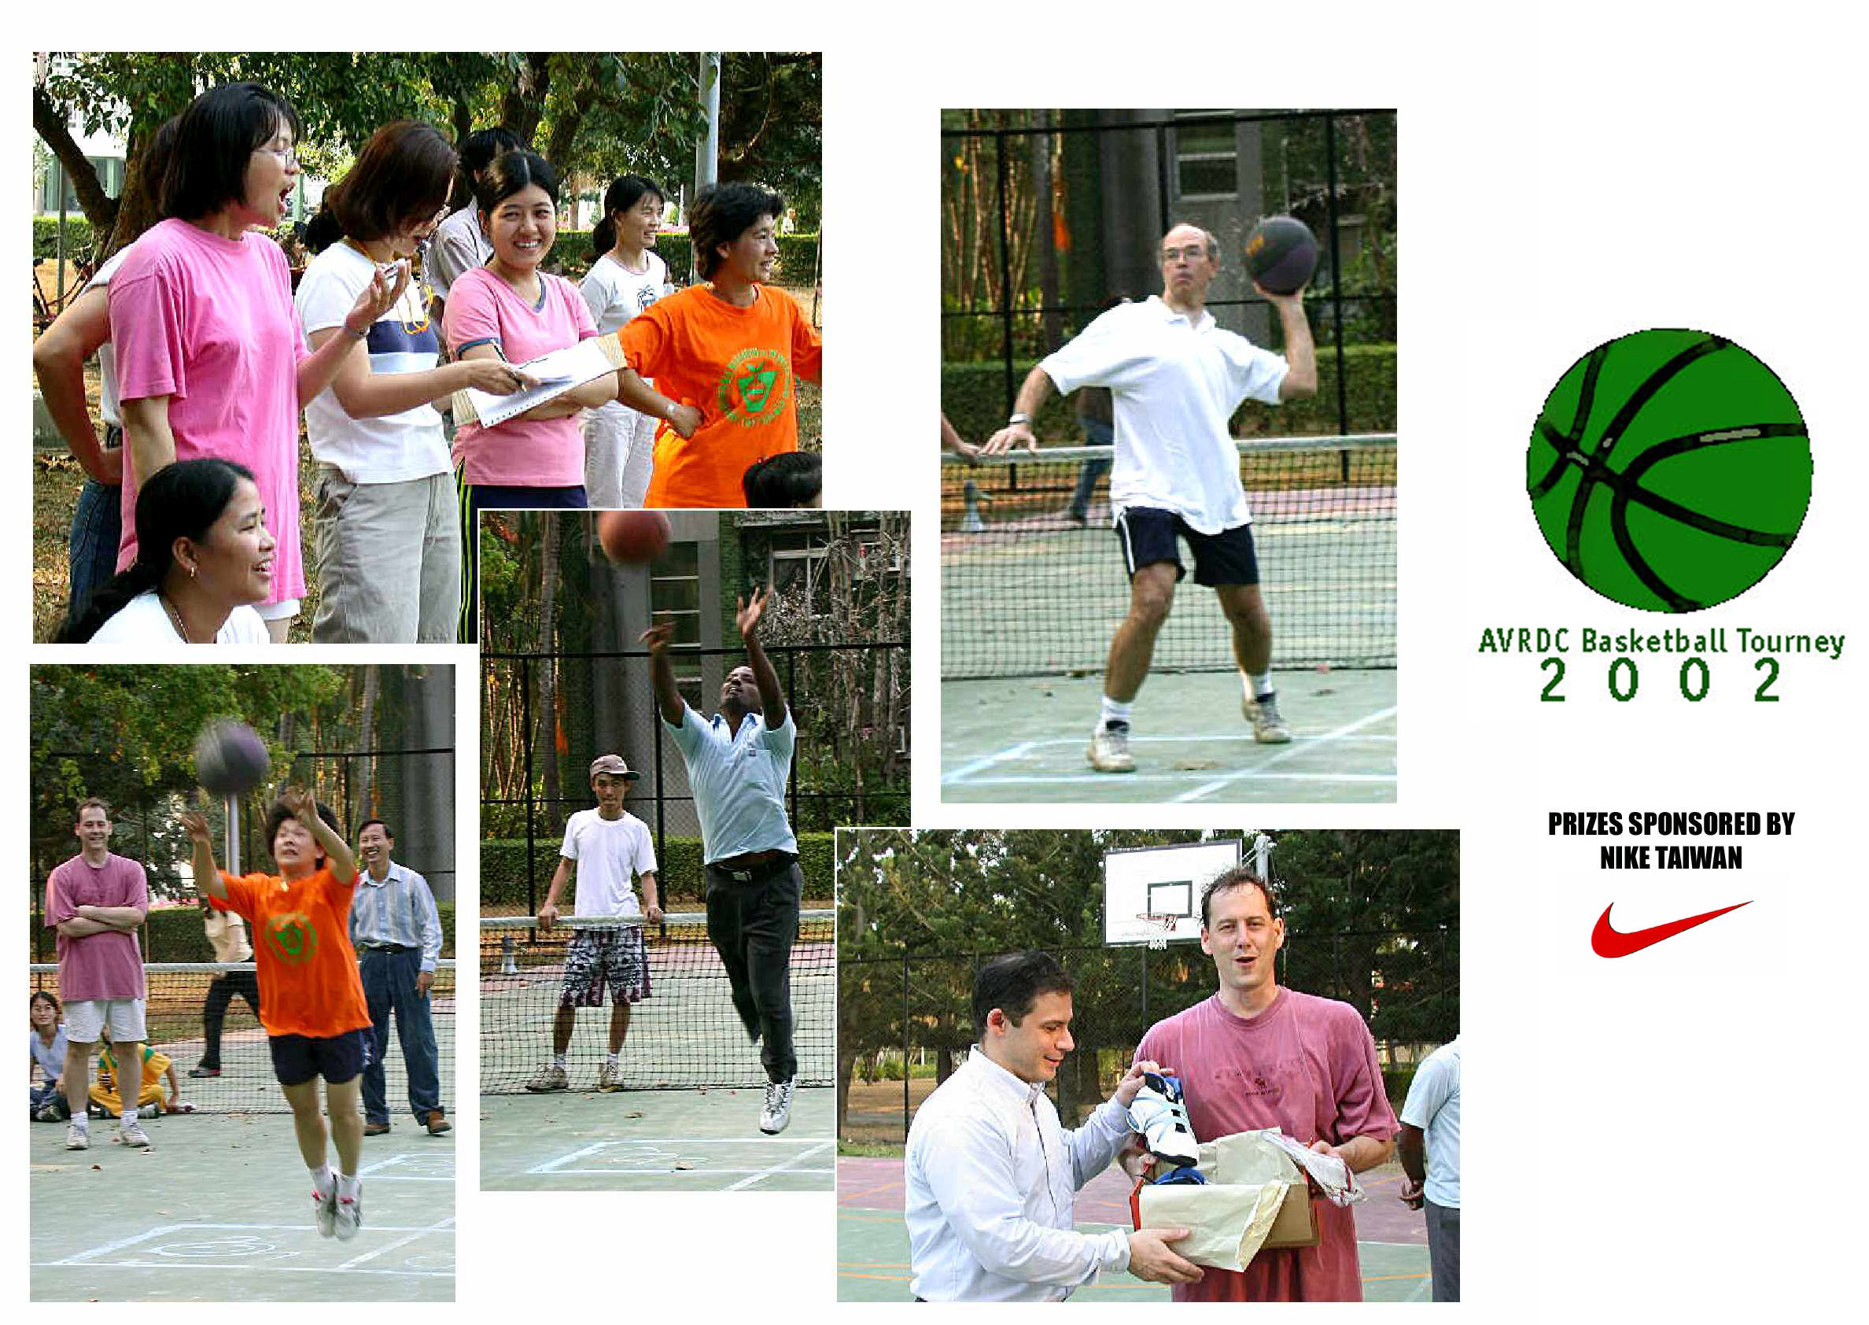
The 2002 AVRDC Basketball Tournament’s Hot Shot contest saw (Miss Yang Li-hwa) fire off 11 baskets for a total 22 points to better Tom Kalb’s 18 points and walk away with the grand prize. Finishing in third place was the library’s Mark Teng with a total 12 points and Abera Tesfaye wound up with 8 points including a last-second 4-point shot at the buzzer to help double his score. All winners received either athletic footwear or basketballs compliments of Nike Taiwan. In the long-distance shooting contest, seven people (Abera Tesfaye, Yang Li-hwa, Ma Mau-lung, Chen Jyh-chin, Mark Teng, Claire Weng, and Vivian Wang) split the grand prize of NT$1000, with Abera Tesfaye taking an extra share of the winnings for hitting the rim twice. The AVRDC’s Recreation & Social Committee would like to especially thank Nike Taiwan for providing complimentary basketball footwear and equipment as prizes. Also, thanks goes to Adrienne Mak and Tom Kalb for setting up the action-packed tournament. Finally, thanks to everyone who played during lunch last week during the 3-on-3 tournaments. It was fun! While the NCAA college championships may provide more skill, the AVRDC’s version of “March Madness” certainly showed alot of enthusiasm! Good job to all involved!
2002年的亞蔬盃灌籃比賽，楊麗樺個人投進11球獨得22分奪得錦標，氣走得到18分的亞軍卡博，季軍是圖書館的鄧可聖得了12分，第四名則由衣索匹亞學員Abera Tesfaye，在時間到的哨聲響起，一陣歡呼聲中入籃得4分，以總分8分的成績獲得殿軍，所有入選者都得到主辦此次比賽同仁細心挑選的運動襪以及台灣耐吉公司贊助的籃球鞋及和籃球。中線投籃Abera Tesfaye、楊麗樺、馬茂隆、陳至欽、鄧可聖、翁儷倩、王嫣薇等人的球碰到籃框，因此7個人共同分享了獎金1000元，而其中Abera Tesfaye在每人兩次投籃機會中，兩次球都碰到籃框因而得了兩倍的獎金。康委會特別感謝台灣耐吉公司贊助這次灌籃賽的獎品，也謝謝麥素慧及卡博用心安排全部的賽程，同時，更要謝謝在上週參加3對3鬥牛賽的同仁，我們都打得很開心！如果美國大學運動聯盟要想傳授一些功夫密訣，亞蔬這「三月籃球癡」的朋友們可是會照單全收喔！再次感謝大家的參與！
- Source: CTO
Dancing Lessons and Practices
The lunchtime dancing class is now underway. Classes are on Tuesdays from 12:00 to 12:45 pm in the cafeteria. Also, everyone is welcome to attend the dancing practices on Tuesday nights at 5:00 pm. Please contact Mandy (ext. 564) for details on either the dancing class or practices.
每週二中午時段的國際標準舞課程12點至12點45分在餐廳二樓交誼廳授課，仍陸續招生中！歡迎所有的朋友參加週二晚間的練習，時間是下午5點開始，欲知舞蹈課程或練習詳情請洽林麗珠（分機564）。
- Source: Dr. Tom Kalb
PU YUAN: A STEP BACK IN TIME IN NEARBY HSIN SHI
For those of you who enjoy taking in an occasional afternoon of tea and snacks in traditional Chinese settings, a good place to go is Pu Yuan, located in nearby Hsin Shi. Filled with traditional Chinese furniture and a myriad of teapots and curios for sale, it is a pleasant place to sip some tea, munch on some snacks, and discuss the latest developments in international agriculture. Pu Yuan is located at No. 126 Nankang Street, Hsin Shi (Tel: 501-1151) and resembles a Chinese temple.
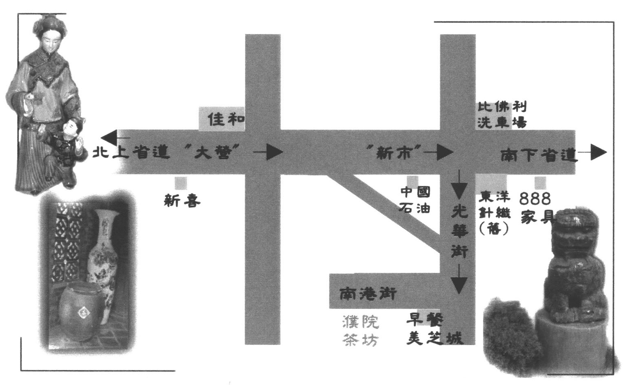

想要擁有一個午后的閒情逸緻嗎？位在新市的濮院是個不錯的選擇，中國式的庭園建築，花木扶疏古意盎然，三五好友相約品茗吃茶食，或共赴午餐上談古今，下掰今後國際農業發展趨勢，順便可以欣賞一下那裡的新奇擺飾、各式各樣的茶壺，如果興緻高的話，還可以選一兩樣帶回家呢！如何？心動不如行動吧！（濮院茶坊－新市鄉南港街16號，電話501-1151）
- Source: CTO
New definitions
- Compromise : The art of dividing a cake in such a way that everybody believes he got the biggest piece.
- Tears : The hydraulic force by which masculine will-power is defeated by feminine water power...
- Dictionary : A place where success comes before work.
- Source: Olivia Liang

 | Weather Summary (21–27 March 2002)
 | Temperature (°C) | Max |  | Min. |  | Monthly precipitation record (mm)
 | Absolute | 30.7 |  | 18.8 |  | Accumulation to date | 2.0
 | Weekly mean | 28.9 |  | 20.4 |  | Normal (March) | 44.9
 | Normal (March) | 26.5 |  | 15.5
 |  |  |  |  |  | Yearly precipitation record (mm)
 | Relative humidity (%) | 99.4 |  | 67.7 |  | Accumulation to date | 24.0
 | Evaporation (mm) |  | 31.2 |  |  | Normal (January to March) | 93.1

